1. **Home page logo link**

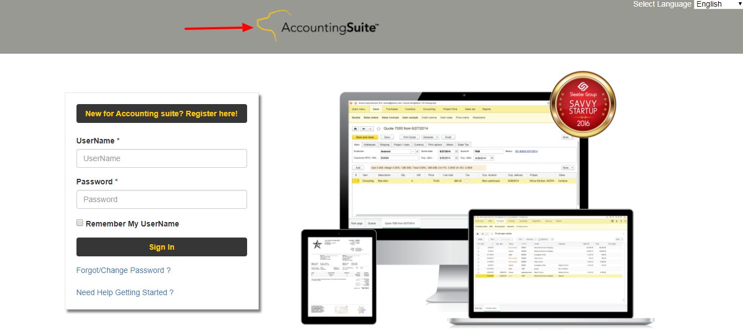

**File Location:** /var/www/html

**File Name:** header.html

**Change Line Number:**  2

**Change Text:** <http://64.91.247.119:8888/#/>

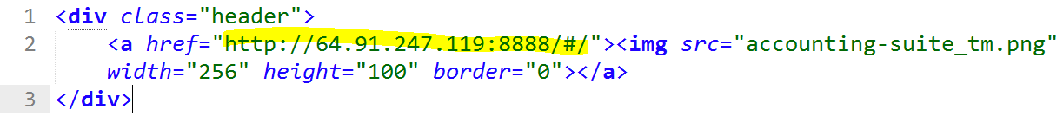

1. **Home page Footer links**

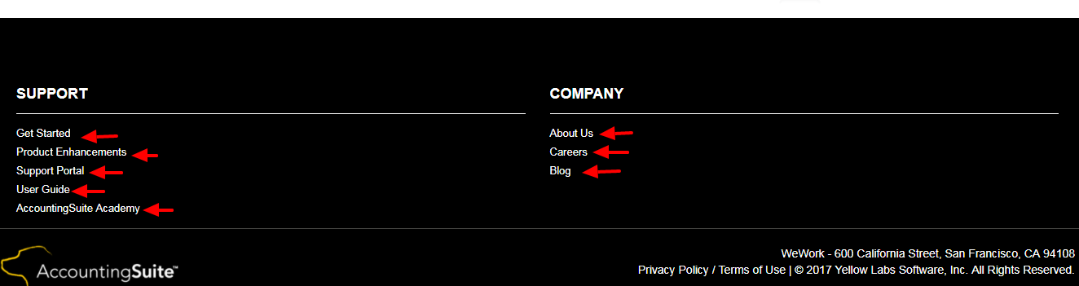

**File Location:** /var/www/html

**File Name:** footer_inner.html

1. Get Started link



1. Product Enhancements



1. Support Portal



1. User Guide



1. AccountingSuite Academy



1. About Us



1. Careers



1. Blog



1. Inner Header links

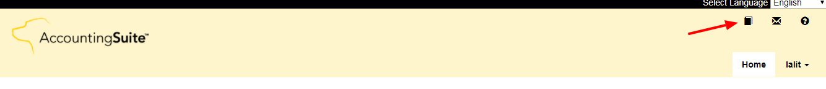

**File Location:** /var/www/html

**File Name:** header_inner.html

1. Logo link



1. Userguide



1. about-contact



1. help

